1.The gain of an amplifier can be controlled by this resistor.

2.The ideal op amp the current at inverting and non-inverting

terminals.

3.The weighted sum of several voltages in a circuit can be obtained by using this circuit.

4.A signal source vf with no connection to the ground.

5.By replacing the feedback resistor in an inverting amplifier by capacitor and inductor we obtain the following circuits respectively. 6.What is the comparator output at the two cases.

V1 > vo

V1< vo

7.Output f and g for the diagram as functions of the 3 inputs a,b and c.

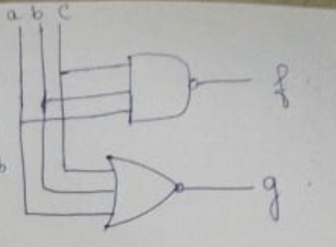

8. 2’s complement of 11011010.

9. ASCII equivalent of $.

10.Flip flop is a how many bit memory cell.

11.The use of flip flop.

12.The 8-bit register consist of how many flip flop.

13.The SR latch is also called.

14.

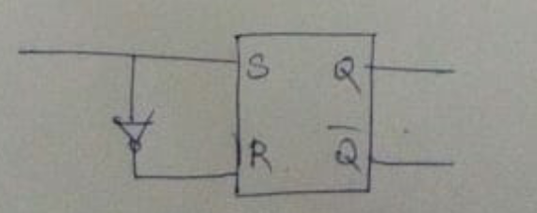

The circuit is ------------- flip flop.

15.Another name for multiplexer.